**Emotion Detection from Text**

**Ahsanullah University of Science and Technology**

**Computer Science and Technology Department**

***Project Proposal***

Pattern Recognition Lab

Course No. CSE4214

Group No.: 04

**Course Teachers:**

1. Faisal Muhammad Shah

Associate Professor

CSE, AUST

2. Md. Tanvir Rouf Shawon

Lecturer

CSE, AUST

**Group members:**

1. Nowshin Rumali

ID: 160204107

2. Rejone-E-Rasul Hridoy

ID: 170104116

3. Mehedi Hasan Sami

ID: 170104118

**Introduction:**

Emotion is one of the basic instincts of a human being. Emotion detection plays a vital role in the field of textual analysis. At present, people’s expressions and emotional states have turned into the leading topic for research works. Emotion Detection and Recognition from texts are recent fields of research that are closely related to Emotion Analysis. Emotion Analysis aims at detecting and recognizing feelings through the expressions from sentences, such as anger, surprise, joy, disgust, sadness etc. For detecting emotions we will use some machine learning algorithms.

**Dataset:**

We will use tweet emotions dataset from kaggle which has 20000 unique text classified with 6 emotions such as anger, love, surprise, fear, joy, sadness. This dataset has two columns content and sentiment. Content column contains text data and the sentiment column contains the emotion with respect to that text.

**Methodology:**

1. Cleaning the dataset: remove punctuation, stopwords and performing stemming/lemmatizing.
2. Applying Feature Extraction: Count Occurrence, TF-IDF.
3. Applying different machine learning algorithms such as Support Vector Machine (SVM), Multinomial Naive Bayes, etc. to build the model.
4. Testing the model and finding accuracy.
5. Predicting emotions from real-life text and comparing the result for different algorithms.

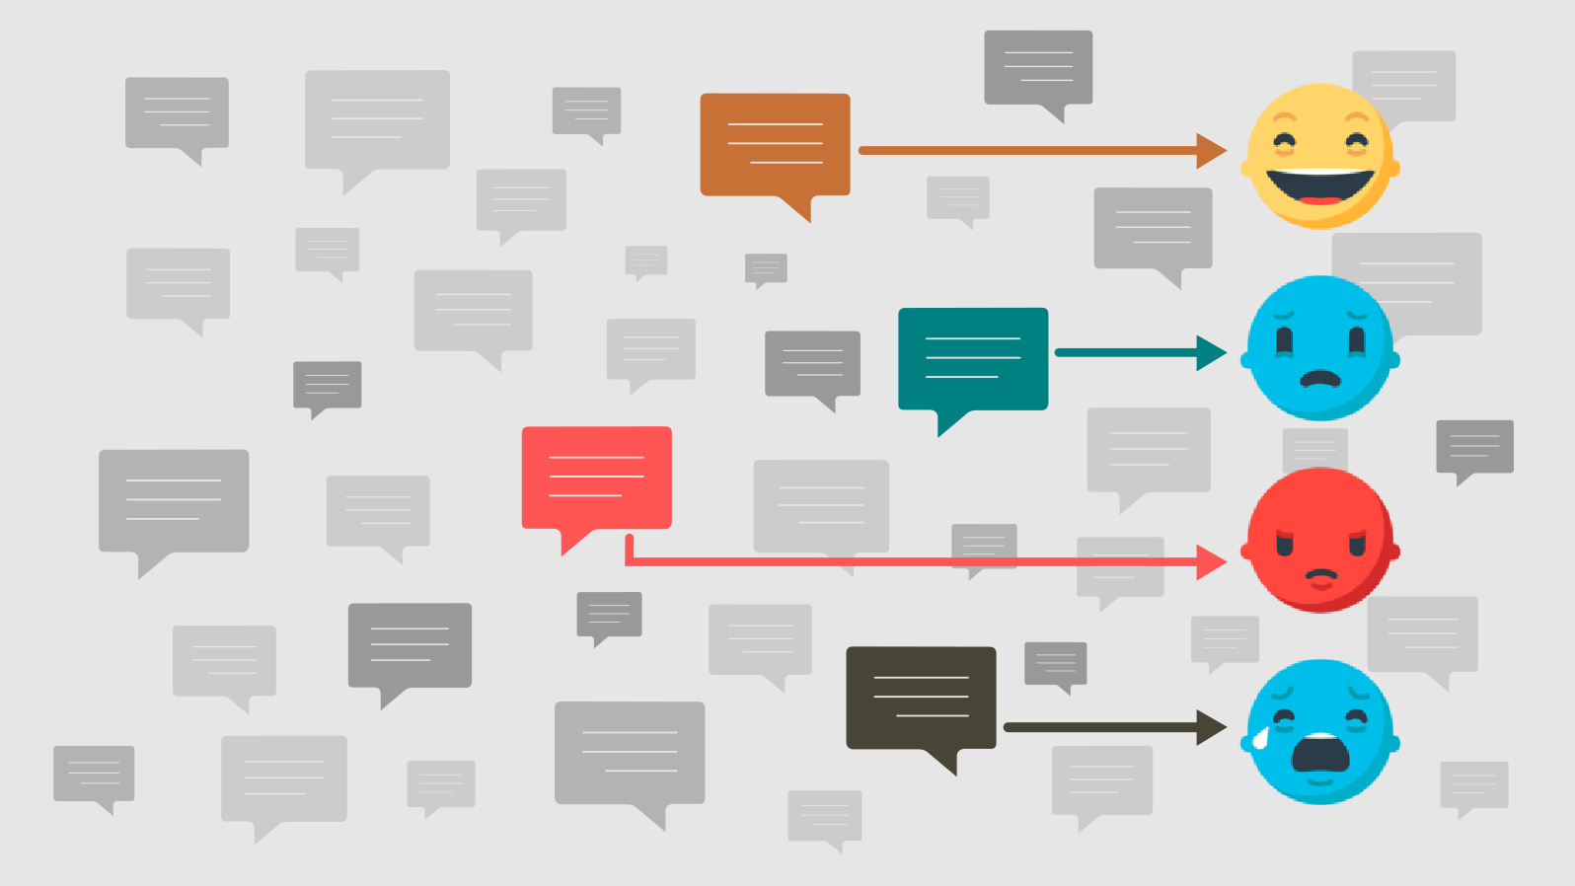

Figure: Emotion Detection from Text